Ananya Jha

Date- 04/06/2025

Guided Project I

Understanding Student Satisfaction

Understanding Student Satisfaction: A First-Year Feedback Analysis

Overview

The main goal of this project is to analyze student satisfaction levels among first-year students at college. We aim to understand why some students enjoy their first year while others struggle – despite the same inputs in faculty, resources, and schedule.

Vision

To help every student enjoy their first year by finding a balance between academics, social life, and personal wellbeing.

Problem Statement

Many first-year students have different experiences at college – some love it, others struggle. But what exactly drives student satisfaction, and how can we improve it?

Project Objective

To collect and analyze feedback from first-year students to identify key factors that affect their satisfaction and recommend practical improvements to enhance overall student experience.

Current Status of Students

Some students seem to be enjoying the college events a lot but struggle academically, whereas others seem to be excellent with their academics but ignore college events. The difficulty in maintaining a good CGPA while also giving time to family and friends still persists.

Student Profile to be Targeted

1. First-Year Students
2. Lower-, middle- and upper-class families
3. Those who seem to be enjoying
4. Those who seem to be struggling
5. Student classification:
6. Socially Active, Academically Struggling
7. Academically Strong, Socially Disconnected
8. Balanced Performer

Stakeholders Involved

This project focuses on students as primary users, but several other stakeholders are impacted by or responsible for improving student satisfaction:

* **First-Year Students** – End users whose feedback drives the analysis.
* **Faculty Members** – Responsible for academic delivery and support.
* **College Counselors** – Help students manage stress and give course/career guidance.
* **College Administration** – Decision-makers who can implement policy-level improvements based on insights.

Google Form Survey

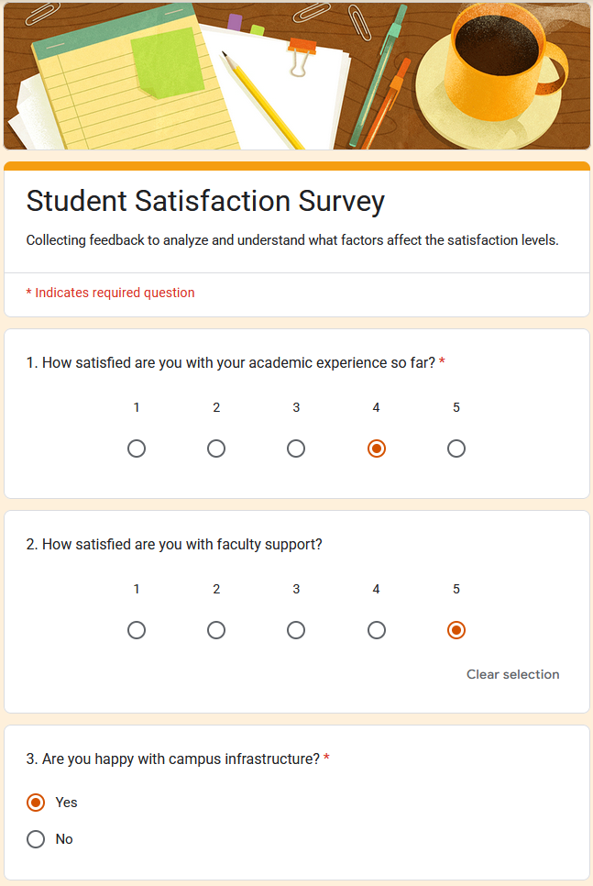

Drawing Insights

* What are students most happy with?
* What areas need improvement?
* Any common themes in praise or complaints?
* What % would recommend the college?

1. What are students most happy with?

* 77% and of the students are satisfied with faculty support, and 73% with the university’s infrastructure. Besides this, the students also appreciate friendly classmates and helpful seniors. The college events also seemed to be enjoyed and have had good remarks.

1. What areas need improvement?

* Most of the students are overwhelmed by the academic pressure and lack of counseling. A few also stated that more events were needed. Only 41% of the students are satisfied with their academics and only 47% of students found the course content to be relevant.

1. Any common themes of praise or complaint?

* Common praises: friendly classmates, helpful seniors, good college events
* Common complaints: lack of counseling, high academic pressure

1. What % would recommend the college?

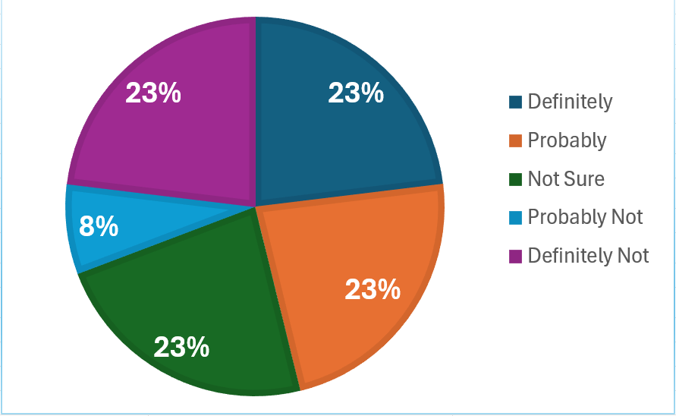

Core Problem in Student Satisfaction

As per the data insights from analysis of the data drawn from the survey, we now know that most of the students are not satisfied with their academia.

Root Cause Analysis

From the patterns observed, academic dissatisfaction emerged as the primary issue. Below is the root cause analysis outlining contributing factors.

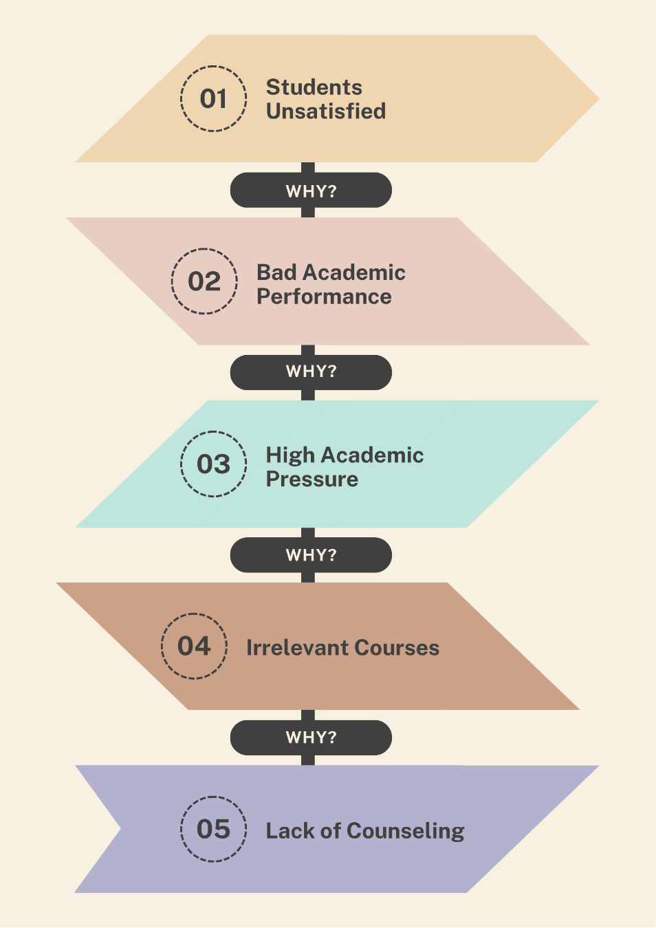

Steps for Improving Students’ Academics

1. Recruiting more counselors to:
2. Help students handle academic pressure and
3. Understand the relevant courses for them.
4. As per recommendations, more college events need to be introduced so that the students don’t get overwhelmed with academics.

Improvements’ Outcomes

Through regular counsel, the students will understand the relevant courses for them and hence not get too pressured by academics. This will significantly improve the academy of the students and their satisfaction levels. In addition to regular counsel, more college events will prevent students from getting overwhelmed due to academics and will allow them to balance their enjoyment and studies.

Project Reflection

This was my first guided project, and the experience helped me significantly in understanding and applying the role of a Business Analyst. With step-by-step support from ChatGPT, I was able to navigate through stage confidently. The guidance included helping me design the survey, generating mock responses for 15 students, and offering direction whenever I felt stuck or unsure about the next step.

The guided project helped me learn how to solve a real-world issue by breaking it into smaller steps. Creating a survey on Google Form helped me understand how to collect relevant and focused feedback, while working with Excel gave me my first hands-on experience with data analysis and visualization.

I realized that small improvements - like increasing counseling and hosting more college events - can have major impact on student satisfaction. Understanding the problem and providing solutions backed by data was genuinely enjoyable.

One of the most important lessons I learned is that you don’t need to know how to code to become a Business Analyst. It’s about asking the right questions, understanding needs and transforming data into meaningful insights that lead to action.

Moving forward, I feel more confident about analyzing datasets and presenting insights clearly. I now understand how to bridge the gap between raw data and human understanding. In future projects, I plan to focus more on the visualization side using tools like Power BI or Tableau to create more impactful dashboards and presentation.